# EEE109 Lab 2 – Transistors

# (Lab Report)

**Student ID numbers:** *1928748*

**Submission date:** *Dec. 9th ,2020*

### *Abstract*

*In this experiment, we will explore the basic characteristics of the bipolar junction transistor. You required to clarify each pin of the transistor and try to verify why the transistor can be equivalent to two junctions. Then, you should construct a circuit and plot the input and output characteristics under different conditions. After that, analyse these waves and reach out the solutions which we have talked about on the lecture. Then, set up a common-emitter amplifier circuit to search the relationship between input and output signal and compare it with the predict value. Set the input signal to 0 and analyse why DC value should be set up. Afterward increase the input signal and observe when the output signal will be clipped and verify why it is clipped.*

### Background

Bipolar Junction Transistor (which is also called BJT) is a three-terminal semiconductor device consisting of two p-n junctions [1]. The three terminals of BJT are base, collector and emitter. There are two types of bipolar junction transistor-NPN transistor and PNP transistor. We will use a 2N3904 transistor in this experiment, which is an NPN transistor. Transistor is now widely used to amplify or magnify a signal. The invention of the transistor changed the structure of electronic circuits and develop the integrated circuits and large-scale integrated circuits [1]. In this experiment, we will search the input and output waves of the BJT and analyse its characteristics. Then, we will construct a common-emitter amplifier circuit to explore how does the transistor magnify the signal. After that, we will talk about something that we should pay attention during the experiment and some methods that can improve this experiment. Finally, there will be a conclusion to summarize this experiment and give some suggestions for the experiment.

### Aims and Objectives

1. Transistor diagrams and connections

1.1 Use the DMM to find the collector pin, base pin and emitter pin.

1.2 Judge whether this BJT is an NPN transistor or PNP transistor. After that, measure the turn-on voltage for the two junctions.

2. Find the input characteristics for BJT.

Construct the circuit according to Figure 1 and set VCE = 5V when VB=0V.

2.1 Find the relationship between IB and VBE. Plot a curve for IB against VBE, which is the input characteristic.

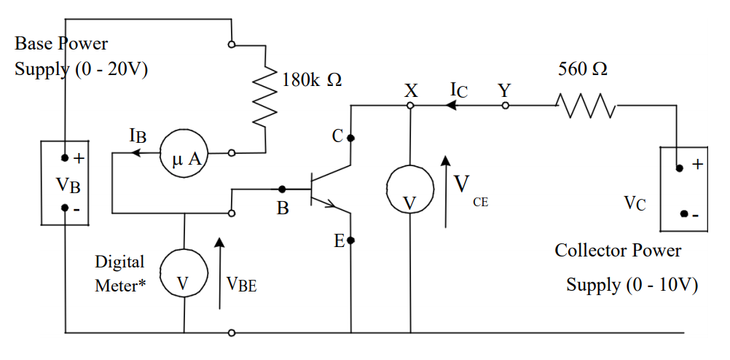 2.2 Change the value of VCE to 10V and plot the curve for IB against VBE. Then, compare the two graphs and find the relationship between them.

Fig 1: Circuit diagram for measuring transistor characteristics

3. Find the output characteristics for BJT.

Construct the circuit according to Figure 1.

3.1 Change the value of VB and record the magnitude of IB. Then, find the relationship between IC and VCE and plot the graph.

3.2 Change the value of IB and explore the relation between IC and VCE. Then, plot the graphs in the same coordinate with the graph in 3.1. After that, find the regulations between different graphs.

4. Common-Emitter Amplifier

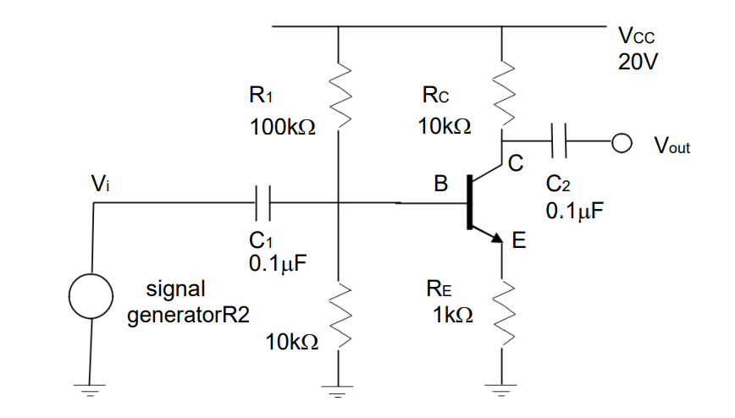Construct the circuit according to Figure 2.

Figure 2: Common-emitter amplifier

4.1 Use the signal generator to produce an input sinusoidal wave. The magnitude and frequency of the input wave should be 0.5V and 5kHz. Then, use the oscilloscope to measure the output voltage and compare the input and output voltage.

4.2 Set the input signal to 0V. Then, find the value for VB, VBE and VCE. Think about why they should be like this.

4.3 Increase the input signal and find the change for output voltage.

### Experiment/Methodology

For the first experiment, we can use the DMM to clarify the pin of the transistor. In DMM, there is a gear called “HFE”, which is used for measuring the current magnification of the transistor. We can find different pins according to the label on the DMM when we see changes on the screen. It is quite convenient.

Figure 3: DMM (Red circle: Place to judge different pins; Blue circle: Diode gear)

Then, we can use the “diode” gear to find the voltage between the two junctions.

For the second experiment, we first construct the circuit according to figure 1. There is a notice that you should use Bench multimeter to measure the value of IB. That is because the Bench multimeter could measure IB more accurately. Afterwards, change the value of VB and obtain different values for IB and VBE. In this experiment, we measured the values of IB and VBE in eight different values of VB so that we can plot the graph more accurately. After that, change the VCE to 10V and gauge the magnitude of IB and VBE under the same values of VB. After the second experiment, we use the simulation software to check whether there are some mistakes in our statistics and we can do the experiment again and fix statistics. During the experiment, the measured values for IB fluctuated in a large range which confused our group. Then, we replaced with another Bench multimeter, and the values became stable. In the following time, you should check the accuracy of the instrument before the experiment begins. Otherwise, it will affect your experiment process.

The process for the third experiment is quite similar to the second experiment. You should use the DMM to measure the values of IC. We measure the values for VCE and IC under twelve different magnitudes for VC to acquire an appropriate graph.

In the fourth experiment, construct the circuit according to Figure 2. You should calibrate the Oscilloscope before doing the experiment. Then, set the magnitude and frequency for Function generator as the input signal. If it is difficult for you to find the marginal value for the output voltage, you can press the “Stop” button to measure the value. Then, set the signal generator to 0 and find the DC value. Finally, connect the signal generator again and do the final experiments. You should adjust the positions of the input and output signal in the same coordinates on the screen so that it will be convenient for you to find the change between different magnitudes of the input signal. After the experiment, we also use simulation software to verify our solution.

After the whole experiment, I used Matlab and LTspice to plot the graphs for the experiment in order to obtain more accurate images than plot by hand.

### Results

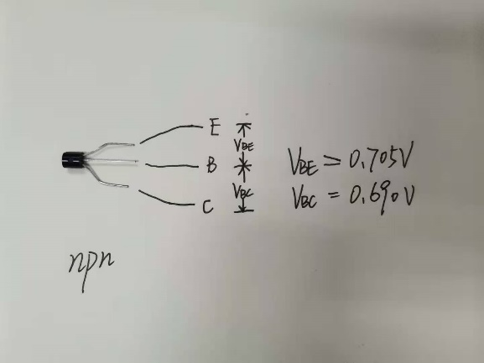For experiment 1, the result is shown below.

Figure 4: The NPN transistor

From figure 4, the top one is the emitter. The middle pin is the base while the bottom one is the collector. What is more, from the “HFE” gear, we find that it is an NPN transistor. The turn-on voltage for the two junctions are VBE = 0.705V and VBC = 0.690V.

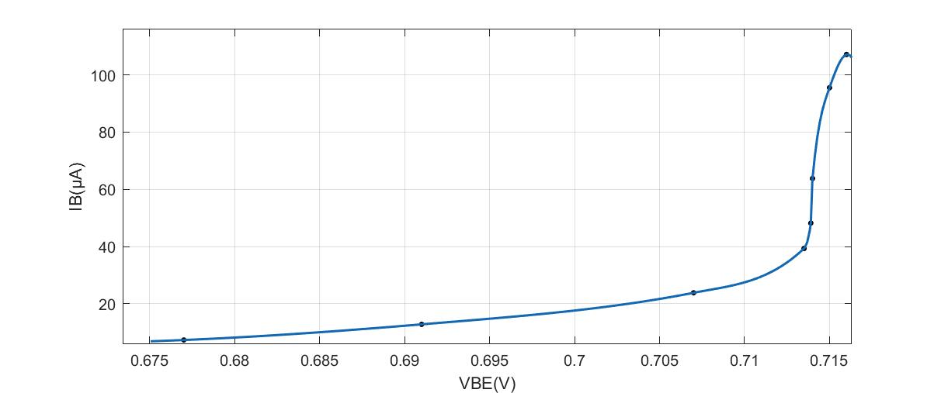For experiment 2, when VCE = 5V, the rough input characteristic shown below:

Fig 5: The input wave when VCE = 5V

If you want to find the detailed values for IB and VBE, you can move to the “Appendix A” to find statistics.

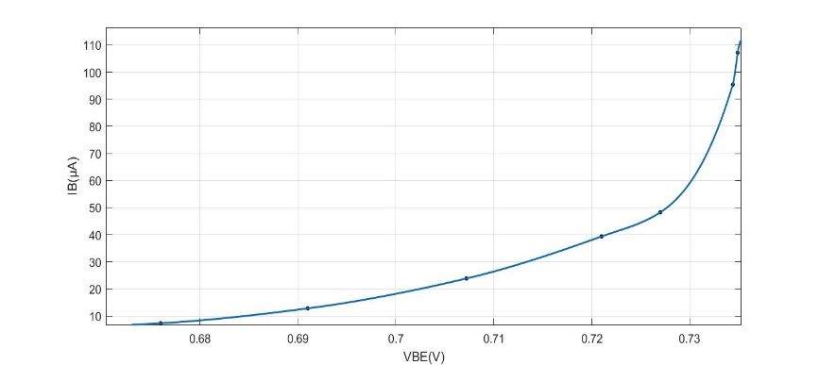When VCE is equal to 10V, the rough input characteristic is shown below:

Figure 6: The input wave when VCE = 10V

If you want to find the detailed values for IB and VBE, you can move to the “Appendix A” to find statistics.

In order to obtain a more appropriate graph, I delete one set of data. That is when VB = 12.2V, VBE = 0.733V and IB = 53.7μA.

Compared to the two graphs, we can find that there is no significant difference between them. But we notice that there is a translation between the two graphs. When you increase the value of VCE, the curve will translate slightly to the right side.

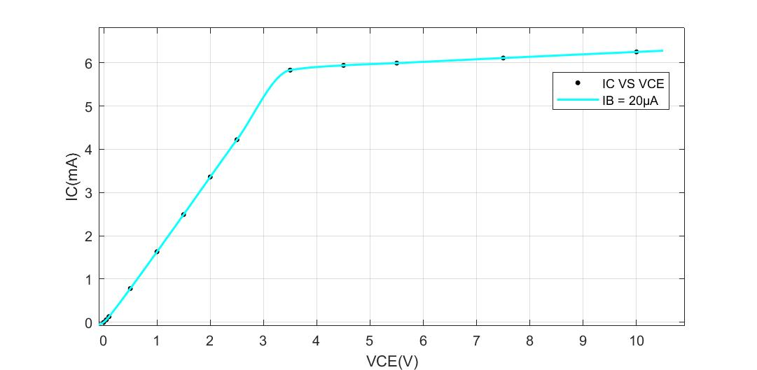For experiment 3, when IB = 20μA, the output characteristic is shown below:

Figure 7: The output characteristic when IB = 20μA

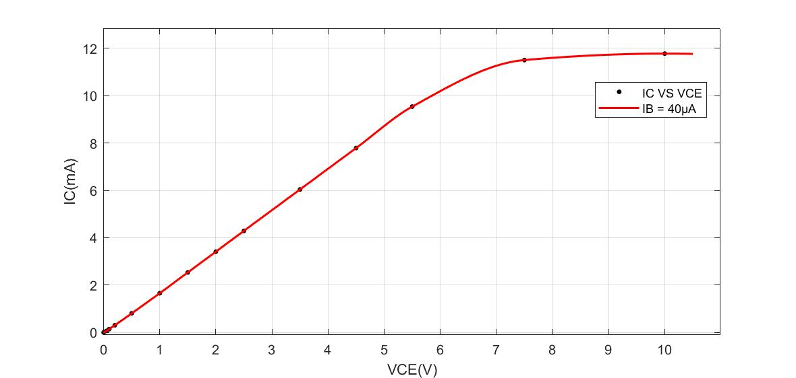When IB = 40μA, the output characteristic is shown below:

Figure 8: The output characteristic when IB = 40μA

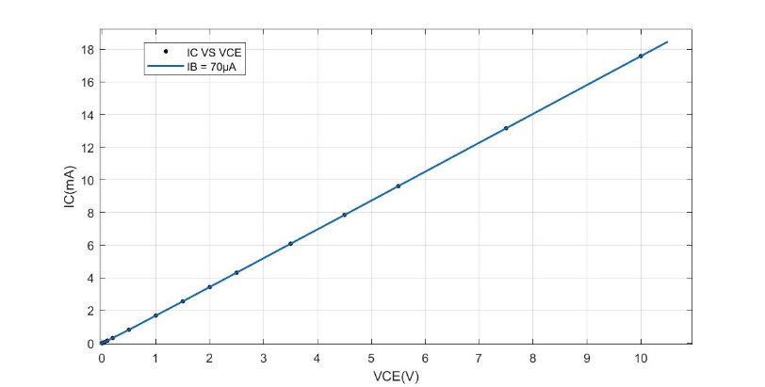When IB = 70μA, the output characteristic is shown below:

Figure 9: The output characteristic when IB = 70μA

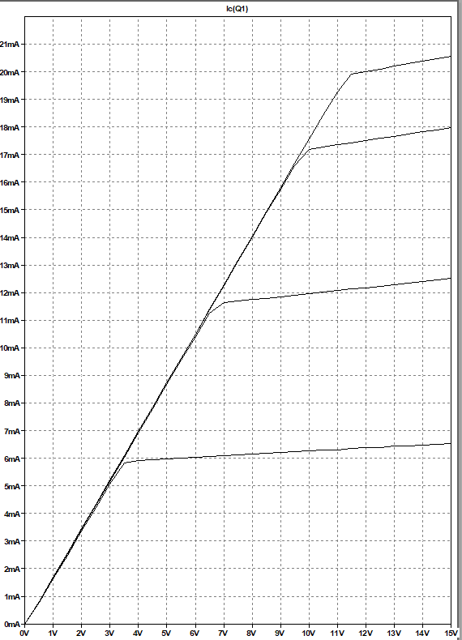If we combine these three curves, we will obtain:

Figure 10: The output characteristics of BJT

If you want to find the detailed values for IC and VCE, you can move to the “Appendix A” to find statistics.

The bottom one is IB = 20μA. The curve above the bottom one is IB = 40μA. The top one is IB = 70μA.

From these graphs, we can find that after reaching a definite value of VCE. The magnitude of the IC will not change rapidly no matter how rapidly the VCE changes. That means the BJT has biased in the forward-active region.

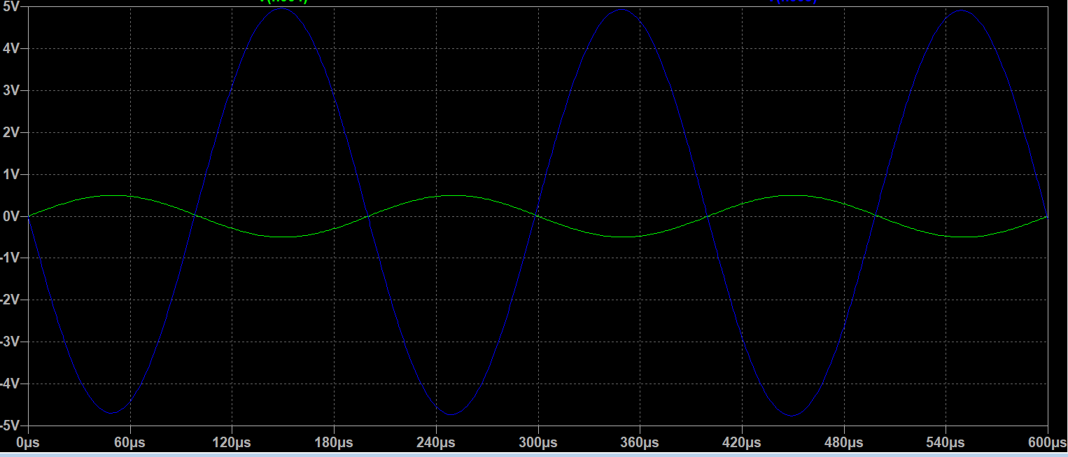For experiment 4, the input and output signals are shown below:

Figure 11: The input and output signal (The green one is input; The blue one is output)

The magnitude of the input signal is 0.5V.

The magnitude of the output signal is about 4.96V.

We can find that the amplification AV is about -9.92, which is quite similar to the predict amplification AV = -RC/RE = -10. The frequency does not change while the phase changes π rad.

When the input signal is 0, The expected value for VB is 1.82V while the measured value of VB is about 1.79V. What is more, the measured value for VBE is about 0.66V. These measured values are quite close to the theoretical values. Apply the 0.5V 5KHz input signal. The minimum value for the input signal is about 1.16V, so that the signal would not be cut-off by BJT.

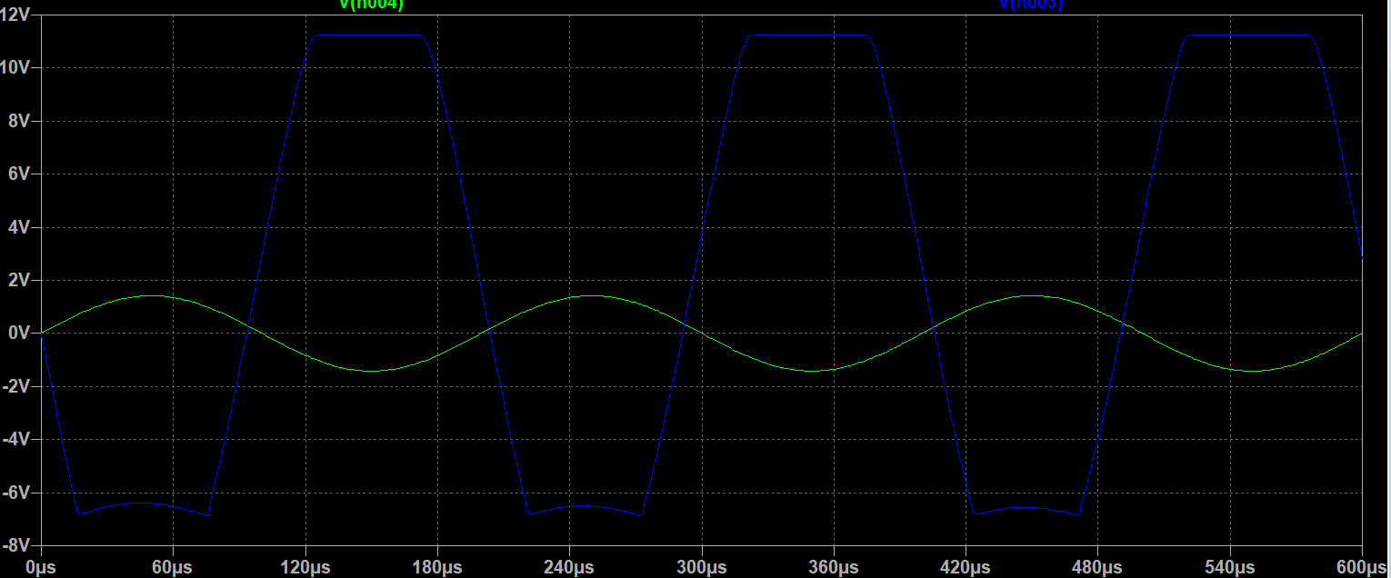 Increasing the magnitude of the input signal to 1.42V. We can observe that the output signal will be clipped. The graph is shown below:

Figure12: The input and output signal (The blue one is the output signal; the green one is the input signal)

The reason why the output signal is clipped is that the BJT changes from the forward-active region into the saturation region. Thus, the BJT could not work as an amplifier. Thus, the output voltage will be clipped.

### Result Discussion

Compared to the results and aims in experiment 1, we can conclude that we achieve the goals. We clarify each pin of the transistor and verify that the BJT can be equivalent to two junctions connected with each other.

For experiment 2, we explore the relationship between the VBE and IB. The input characteristic is similar to the diode characteristic. When the voltage is higher than the turn-on voltage, the value of IB will increase rapidly. This solution testifies the result from experiment 1 as well. Moreover, we also attest that the value of VCE will influence the input characteristic of the BJT. That is because the more electron will move to the collector when you increase the value of VCE. Therefore, the value of IB will decrease and the wave will translate to the right side.

From experiment 3, we search the relationship between VCE and IC. From the graph, we can have a better understanding of why the BJT can be used as an amplifier. When the BJT is biased in the forward-active region, it is easy to find that the value of IC is not constant. That is called the early effect. Due to the early effect, the output resistance r0 could significantly affect the amplifier characteristics. Thus, we should pay attention to the early effect when we use BJT in the following time.

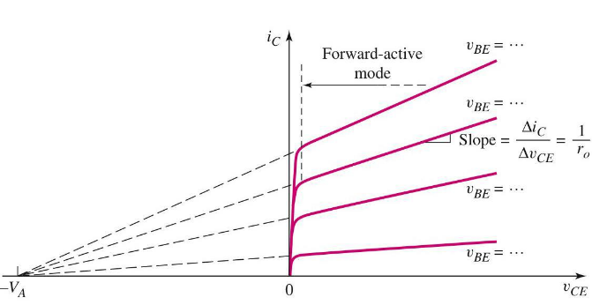 Figure 13: The early effect

For experiment 4, we further explore the use of BJT amplifier. It has the ability to enlarge the input signal. Besides, we need to be careful with the magnitude of the input signal because the BJT can be biased in the saturation region and lose the ability to enlarge the input signal.

During the experiment, you can use simulation software to check whether the values you measured is appropriate, especially for experiment 1 and 2. The value you measured can be quite small and experimental instruments may not measure the value accurately. What is more, you can also use simulation software to predict the experiment values so that you can carry out the experiment more easily.

Furthermore, Matlab is also an important tool to evaluate the experiment results. It can help do complex calculation and plot the graph accurately. Thus, in the future, simulation software and Matlab are useful for you to carry out the experiments.

### Conclusions

In conclusion, we explore the characteristics of BJT. We can use the DMM to judge its pins and verify why it can be equivalent to two junctions. The input characteristic shows there is an equivalent diode between the emitter and the base. It also shows what will happen if we increase the magnitude of VCE. The output characteristics tell us the reason why the BJT can be used as an amplifier. Then, we construct a common-emitter amplifier to further explore its regulations. From the amplifier circuit, we also know why we should control the magnitude of the input signal. During the experiment, you should strictly follow the experimental steps. Some of the measured values in this experiment are very small. There can be a large error if you do not obey the experimental steps rigorously. What is more, you had better check the accuracy of each apparatus before the experiment, so that you will not confuse with the measured value even though you strictly follow the experimental steps.

### References

[1] Electrical 4U, *Bipolar Junction Transistor (BJT): What is it & How Does it Work,* 2020. [online]. Available: <https://www.electrical4u.com/bipolar-junction-transistor-or-bjt-n-p-n-or-p-n-p-transistor/>. [Accessed: Nov.29, 2020]

### Appendix A:

In this section, you will find the detailed statistics for experiment 2 and 3.

Experiment 2:

|  |  |  |
| --- | --- | --- |
| VCE=5V | | |
| VB(V) | VBE(V) | IB(μA) |
| 20 | 0.716 | 107.1 |
| 5 | 0.707 | 23.85 |
| 9.4 | 0.7139 | 48.2 |
|  |  |  |
| 7.8 | 0.7135 | 39.35 |
| 12.2 | 0.7115 | 63.8 |
| 17.9 | 0.715 | 95.5 |
| 2 | 0.677 | 7.356 |
| 3 | 0.691 | 12.83 |

|  |  |  |
| --- | --- | --- |
| VCE=5V | | |
| VB(V) | VBE(V) | IB(μA) |
| 2.0 | 0.677 | 7.356 |
| 3.0 | 0.691 | 12.83 |
| 5.0 | 0.707 | 23.85 |
| 7.8 | 0.7135 | 39.35 |
| 9.4 | 0.7139 | 48.20 |
| 12.2 | 0.7115 | 63.80 |
| 17.9 | 0.715 | 95.50 |
| 20.0 | 0.716 | 107.10 |

|  |  |  |
| --- | --- | --- |
| VCE=10V | | |
| VB(V) | VBE(V) | IB(μA) |
| 2.0 | 0.676 | 7.356 |
| 3.0 | 0.691 | 12.83 |
| 5.0 | 0.7072 | 23.85 |
| 7.8 | 0.721 | 39.37 |
| 9.4 | 0.727 | 48.27 |
| 12.2 | 0.733 | 53.70 |
| 17.9 | 0.7344 | 95.40 |
| 20.0 | 0.7349 | 107.12 |

Experiment 3:

|  |  |  |  |  |  |  |
| --- | --- | --- | --- | --- | --- | --- |
|  | IB=20μA | | IB =40μA | | IB=70μA | |
| VC (V) |  | IC (mA) |  | IC (mA) |  | IC (mA) |
| 0 | 0 | 0 | 0 |
| 0.05 | 0.057 | 0.065 | 0.07 |
| 0.1 | 0.13 | 0.14 | 0.15 |
| 0.2 | 0.44 | 0.303 | 0.32 |
| 0.5 | 0.78 | 0.804 | 0.82 |
| 1.0 | 1.63 | 1.656 | 1.69 |
| 1.5 | 2.49 | 2.534 | 2.56 |
| 2.0 | 3.36 | 3.41 | 3.44 |
| 2.5 | 4.22 | 4.29 | 4.32 |
| 3.5 | 5.83 | 6.04 | 6.09 |
| 4.5 | 5.94 | 7.79 | 7.85 |
| 5.5 | 5.993 | 9.54 | 9.62 |
| 7.5 | 6.11 | 11.508 | 13.16 |
| 10.0 | 6.251 | 11.78 | 17.58 |

### Appendix B: ****Marking Scheme****

|  |  |
| --- | --- |
| **Section Title** | **Marks** |
| Abstract | **5%** |
| Introduction | **5%** |
| Aims and Objectives | **5%** |
| Experiment/Methodology | **20%** |
| Results | **30%** |
| Discussion | **20%** |
| Conclusion | **10%** |
| Reference | **5%** |